Custom filter

**Not forget stop app and run again if you are finish with all !!!!!**

This filter make description should show **only** **the first 50 characters!**

1. Create module folder templatetags

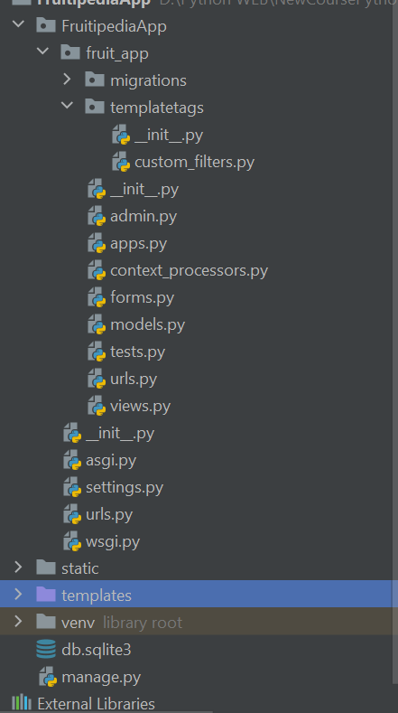

1. Create file custom_filter.py

from django import template  
register = template.Library()  
  
  
@register.filter(name='truncate_chars')  
def truncate_chars(value, max_length):  
 if len(value) <= max_length:  
 return value  
 return value[: max_length] + '...'

3.Load custom_filters in template

{% load custom_filters %}  
  
<!DOCTYPE html>  
<html lang="en">  
<head>  
 <meta charset="UTF-8"/>  
 <meta http-equiv="X-UA-Compatible" content="IE=edge"/>  
 <meta name="viewport" content="width=\, initial-scale=1.0"/>  
 <link rel="stylesheet" href="/static/styles/styles.css"/>  
 <title>Fruitipedia</title>  
</head>  
<body>  
<div id="wrapper">  
 <header>  
 <!-- Navigation -->  
 <a id="logo" href="{% url 'index' %}">  
 <img id="logo-img" src="/static/images/logo.png" alt="logo"/>  
 </a>  
 {% include 'nav.html' %}  
 </header>  
  
 <main>  
  
 <!-- Dashboard Page -->  
 {% if all_fruits %}  
 <h2>Fruits</h2>  
 <section id="dashboard">  
 <!-- Display a div "fruit" with information about each post (if any)-->  
 {% for fruit in all_fruits %}  
 <!-- first fruit -->  
 <div class="fruit">  
 <!-- fruit image -->  
 <img src="{{ fruit.image }}"/>  
 <!-- fruit name -->  
 <h3 class="title">{{ fruit.name }}</h3>  
 <!-- fruit description -->  
 <p class="description">{{ fruit.description | truncate_chars:50 }}</p>  
 <!-- fruit details button -->  
 <a class="details-btn" href="{% url 'fruit-details' fruit.pk %}">More Info</a>  
 </div>  
 {% endfor %}

**Not forget stop app and run again !!!!!!!!!!!!!!!!!!!!!!!**

**If not make this wil recive error**